SACHDEVA COLLEGE OF PHARMACY, GHARUAN
An Industrial visit to

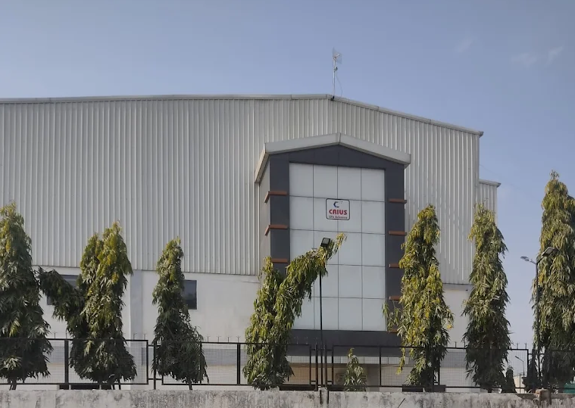
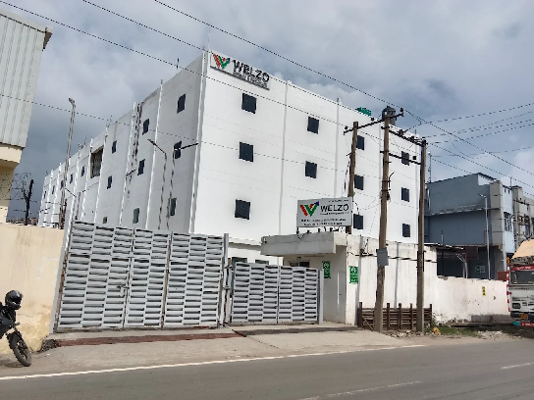
Crius Life Sciences Pvt. Ltd., Baddi Welzo Research & Development Pvt. Ltd., Baddi
An Industrial tour to Crius Life sciences Pvt. Ltd. and Welzo Research and Development, Baddi, Himachal Pradesh was organised for the students of B. Pharmacy 6th and 8th Semester. The areas visited were Tablet, Capsule and Liquid Oral production and packaging departments. The visit was organized on 09 February, 2026 (Monday).
There were about 51 students along with Ms. Reetika Ahuja (Assistant Professor), Dr Vandana Kharb (HOD) and Prof. SP Goel (Dean) visited Crius Life sciences Pvt. Ltd. and Welzo Research & Development. In this visit, various department representatives explained about tablet manufacturing, Quality control, Quality Assurance and packaging processes.
Mr. Chander Mohan (HR Head) Crius Life sciences Pvt. Ltd., Dr. Ashok Kumar (Plant Head) and Mr. Vivek (HR) Welzo Research & Development, Baddi interacted with the students and shared their valuable experience and several crucial aspects about emerging opportunities in Pharmacy field.

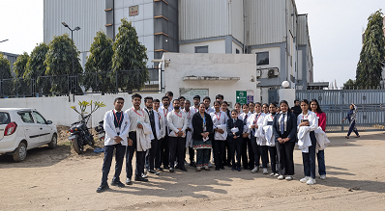
Crius Life sciences Pvt. Ltd. is an ISO-certified, WHO GMP and USFDA Pharmaceutical and Nutraceutical manufacturer based in Baddi, Solan, Himachal Pradesh, established in 2016. The company specializes in contract manufacturing and private labelling of vegetarian soft gels, effervescent tablets and various dosage forms for global markets.
Crius group is a leading manufacturer of Hard capsules, Effervescent powders, Mouth-melt powders, Bubble Gums, and Gummies. Innovative Firsts: World's 1st Oil-Infused Gummies, India's 1st Vegan Softgels, Chewable Softgels. Global Presence: Operating in over 30+ countries, they have built a strong reputation in regulated markets worldwide.
Welzo Research and Development Pvt. Ltd., Baddi is a private company incorporated on 6th Dec 2022. It is classified as Non-government company and is registered at Registrar of companies, Himachal Pradesh. Welzo had proudly inaugurated State-of-the-art Research & Development and Commercial Drug Testing Laboratory at Baddi, Himachal Pradesh, on 17th August 2025. This achievement was made possible under the APICF sub-scheme of the Strengthening of Pharmaceutical Industry (SPI) Scheme by the Department of Pharmaceuticals.
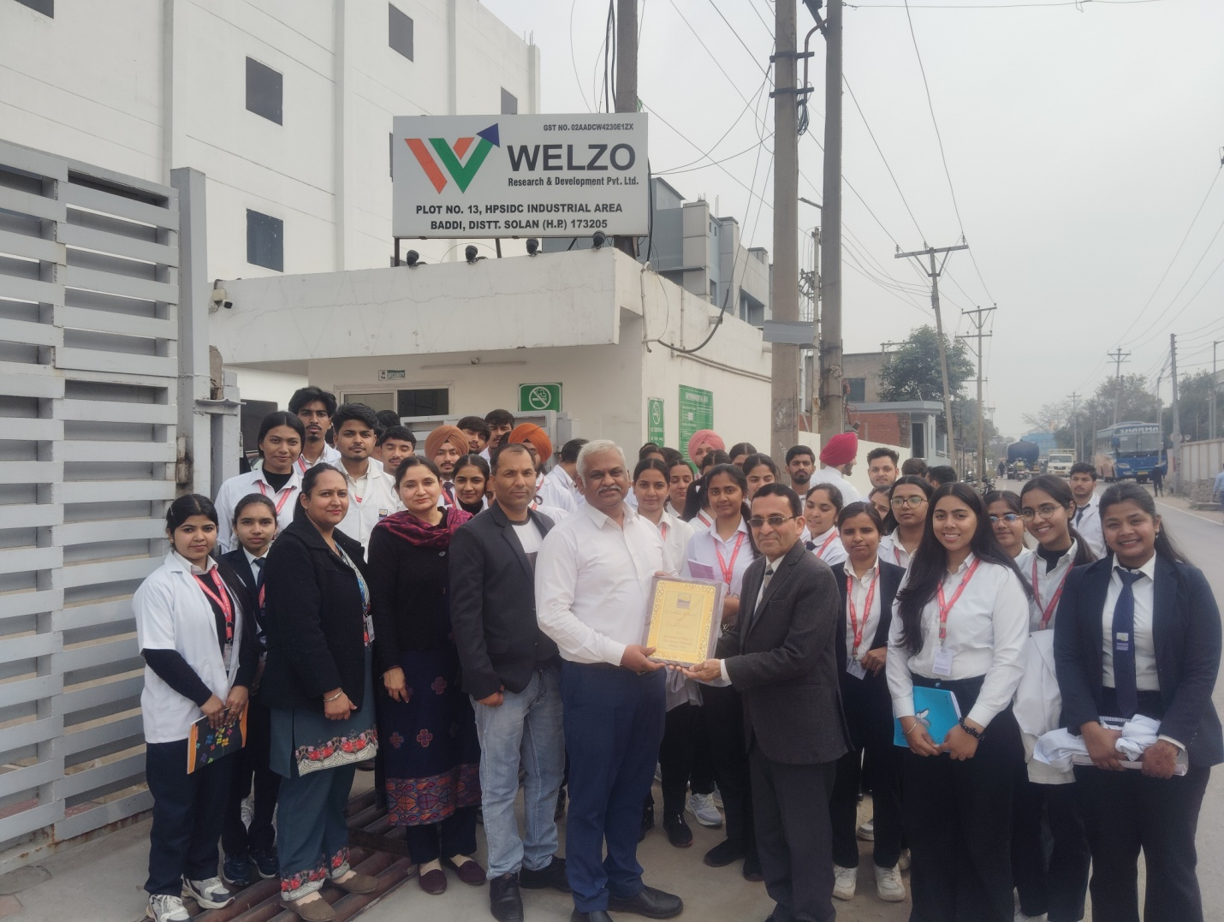
At the end, Prof. SP Goel (Dean) appreciated the efforts of Crius Life sciences Pvt. Ltd. and Welzo Research & Development officials by presenting a souvenir as a token of gratitude and thanked for permitting them to visit their premise. The officials also appreciated college for organizing such a visit which help the students to succeed for their better future.

